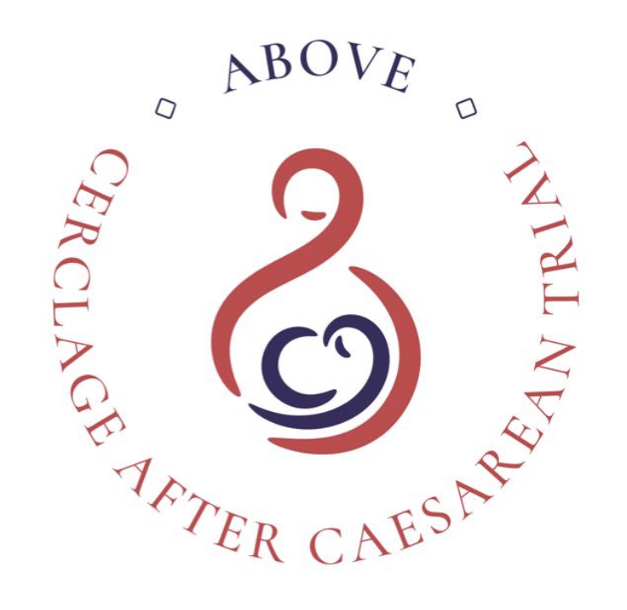
Cerclage after Caesarean: a randomised controlled trial to assess the optimal preventative management for preterm birth secondary to caesarean section damage (ABOVE)

PARTICIPANT INFORMATION SHEET
Observational Study

Invitation to take part
This study is assessing whether a cerclage (a stitch placed around the cervix) is better if it is placed through the vagina, or abdominally (through a cut in the tummy) in women who have had a preterm birth or mid-trimester pregnancy loss (a miscarriage between 14 and 24 weeks of pregnancy) after a previous caesarean section in labour.

In addition to evaluating the two cerclages, we are inviting women who have not been randomised in this study to take part in this observational group. We will be asking if they are happy for us to collect information about what happens to them in this pregnancy and their baby after birth.

Before you decide whether to participate, it is important for you to understand why the research is being done and what it will involve. Please take time to read the following information carefully and discuss it with friends, relatives and your hospital team if you wish. Ask us if there is anything that is not clear or if you would like more information. You will be given as long as you need to read the patient information sheet and consider participation.

What is the purpose of this study?
Recent studies have shown that if a woman has had a caesarean section in labour (when the cervix is opening) she is more likely to have a premature baby in a future pregnancy. We have found that in women who have had an in-labour caesarean section there is a 5-10% chance of a preterm birth in a subsequent pregnancy. Currently, we do not know which treatments are most effective to stop this happening. This study aims to answer this question by determining whether a cerclage, a stitch placed around the cervix, is better when placed through the vagina (transvaginal cerclage) or via an abdominal procedure (transabdominal cerclage) by allocating participants of the randomised study to one of these procedures.
The observational arm will be collecting data about women who are not randomised and receive clinical care from their team. This is very important as the outcomes and experiences of this group of women will provide valuable information as well. Information collected will include medical history including information about previous pregnancies, any treatments to prevent preterm birth received in this pregnancy and delivery outcomes.
We will also be inviting all women taking part in the ABOVE study the opportunity to complete an optional online survey about their experience of the study.

Why have I been asked to take part?
You have been asked to take part because you are currently pregnant or considering a pregnancy and have experienced a mid-trimester pregnancy loss or preterm birth after an earlier in-labour caesarean section. You have not been randomised to one of the cerclages by the study and will be having routine clinical care. Your outcomes and experiences will provide valuable information.
Do I have to take part?
No, it is up to you to decide whether or not to take part. If you decide not to take part it will not affect the standard of medical care you receive.

What will happen to me if I take part?
If you do decide to take part you will be given this information sheet to keep and you will be asked to sign a consent form.

We will ask your permission to look at your medical notes and those of your baby after delivery so that we can find out what happened. If you have your baby in a different hospital we might need to contact your GP or the hospital where you have the baby. Although there are no study follow up visits, we will collect information about the care you receive during pregnancy, which may include scan images of your cervix taken in prematurity clinic.

What are the disadvantages or side effects of taking part?
If you choose to take part, you will need to take time to sign the consent form. We may ask you to answer some questions about yourself and your previous pregnancies. We don’t expect this to be longer than 15-20 minutes.

What are the possible benefits of taking part?
You may not benefit from taking part personally, but what we learn from this study might help us to improve care for women in the future and reduce the number of babies being born too early.

What if I change my mind after agreeing to take part?
You are free to withdraw at any time without your medical care being affected.

Further Supporting Information

The information will be stored on the ABOVE trial database and ABOVE participant details database which are secure web-based platforms provided by MedSciNet, a Stockholm based company specialising in design and development of web applications and online database systems for clinical trials and studies. The data will be held on these databases, and downloaded to a KCL Sharepoint site for analysis. After completion of the study, research data it will be archived in a secure facility called Iron Mountain.

Information on the use of data
How will we use information about you?
We will need to use information from your hospital medical records for this research project. We will collect information on your previous medical history and pregnancies, your maternity care e.g. whether you had any other treatments relating to preterm birth, details about the birth e.g. onset of labour and how many weeks pregnant you were when the baby was born, and whether you and/or your baby had any problems or needed extra care e.g. admission to neonatal unit. We will collect this information during your pregnancy, e.g. whenever you attend specialist preterm clinic appointments, and after your baby has been born.
This information will include your initials, date of birth, hospital number and NHS number, but these identifiers will be kept on a separate but linked participant details database. People will use this information to do the research or to check your records to make sure that the research is being done properly.
People who do not need to know who you are will not be able to see your name or contact details. Your data will have a code number instead.
We will keep all information about you safe and secure.
Some of your information will be sent to Sweden, where the servers for the main study and participant details databases are located. They must follow our rules about keeping your information safe. Appropriate safeguards will be in place, and the legal basis for storage of this data is that “it is a task in the public interest”.
Once we have finished the study, we will keep some of the data so we can check the results. We will write our reports in a way that no-one can work out that you took part in the study.

What are your choices about how your information is used?
- You can stop being part of the study at any time, without giving a reason, but we will keep information about you that we already have.
- We need to manage your records in specific ways for the research to be reliable. This means that we won’t be able to let you see or change the data we hold about you.
Where can you find out more about how my information is used?
You can find out more about how we use your information:

- at www.hra.nhs.uk/information-about-patients/
- our leaflet available from:
www.guysandstthomas.nhs.uk/research/patients/use-of-data.aspx (For GSTT)
and
https://www.kcl.ac.uk/research/research-environment/rgei/research-ethics/use-of-personal-data-in-research (for KCL)
- by asking one of the research team (contact details included below)
- by contacting the Data Protection Officer: (For GSTT: Nick Murphy-O’Kane DPO@gstt.nhs.uk; For KCL: Olenka Cogias info-compliance@kcl.ac.uk)

What if there is a problem?
If you have a concern about any aspect of this study, you should ask to speak to your local Principal Investigator who will do their best to answer your questions [insert name and email address]. If you remain unhappy and wish to complain formally, you can do this through your local hospital Patients Advice and Liaison Service (PALS) [insert details].

In the event that something goes wrong and you are harmed during the research you may have grounds for legal action for compensation against Guy’s and St Thomas’ NHS Foundation Trust and/or King’s College London but you may have to pay your legal costs. The normal National Health Service complaints mechanisms will still be available to you (if appropriate).
What will happen to the results of the research study?
The results will be published in the medical literature and presented at conferences. No participant names or identifiable information will be included. We will write a summary of the findings of the study and make it available on the study website (www.medscinet.net/ukpcn/above). Results will also be published through university, clinical and service user networks using email and social media.

Who is organising and funding the research?
Action Medical Research is funding the research, with sponsorship from King’s College London and Guy’s and St Thomas’ NHS Foundation Trust.

Who has reviewed the study?
This study has been reviewed and approved by this NHS Trust’s Research & Development Department. Health Research Authority and NHS Research Ethics Committee (REC Ref: 24/NW/0093 IRAS ID 327879).

Contact for further information:
*LOCAL Site information here*

